198. Multiple Docker Installations

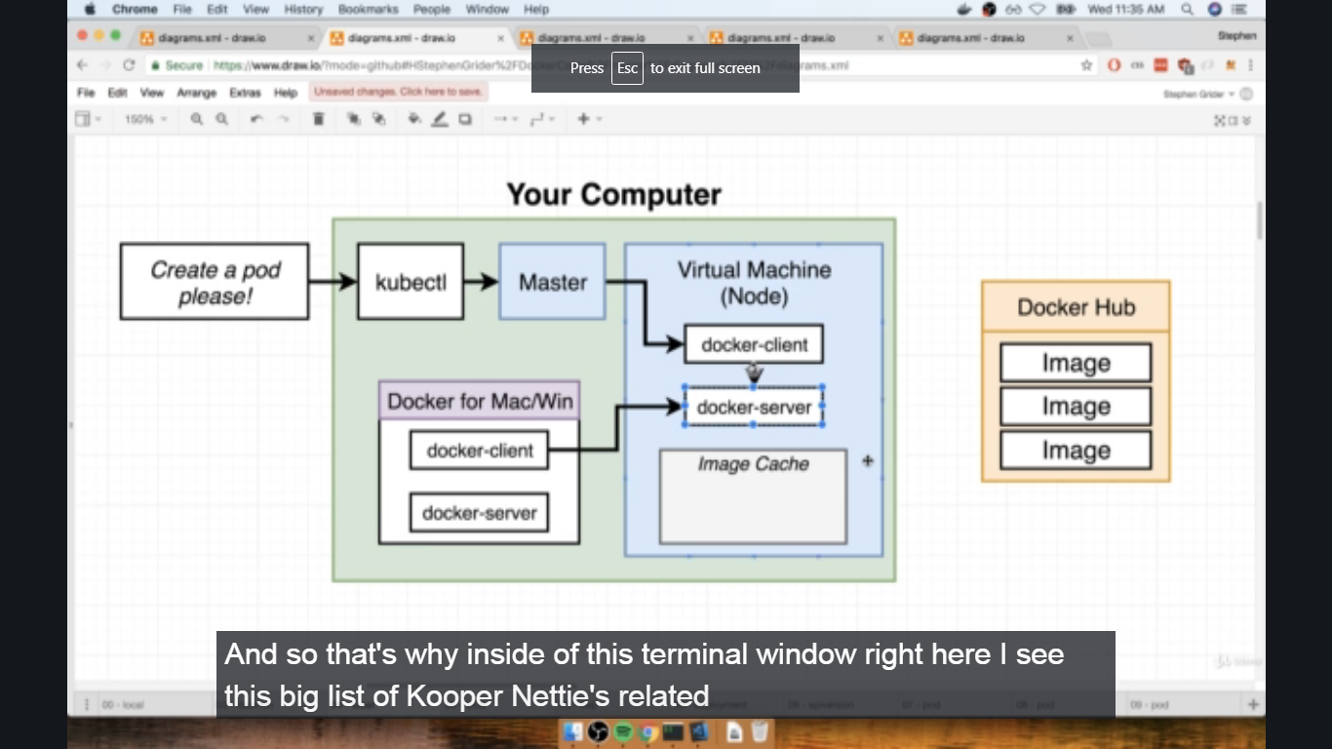

199. 199. Reconfiguring Docker CLI

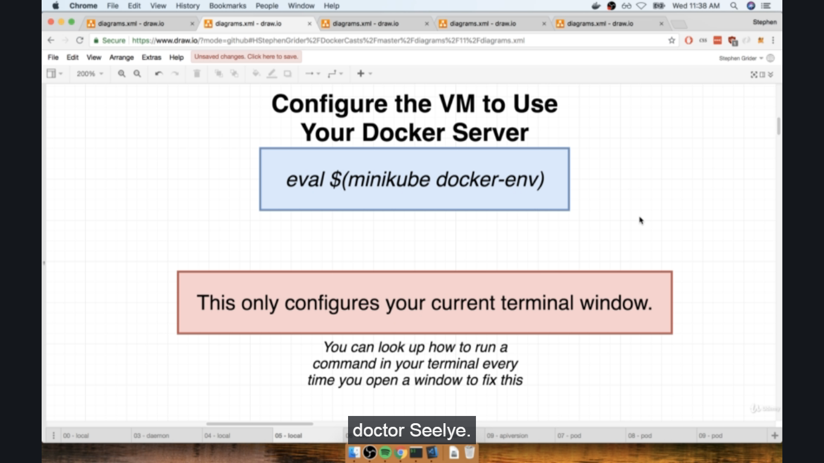

200. Why Mess with Docker in the Node?

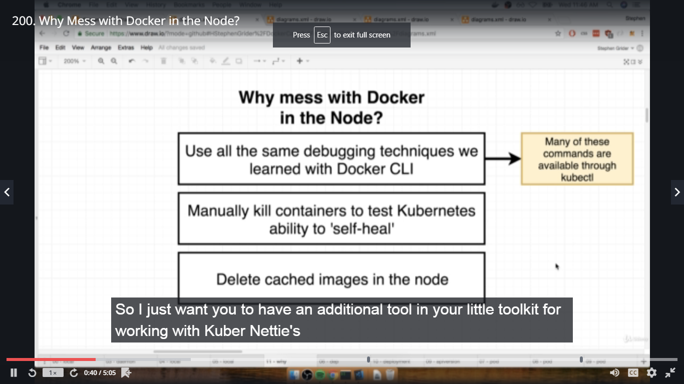

In terminal simplek8s dir,

#docker ps ----- get containerid for multi-client

#docker logs containerid

#docker exec -it containerid sh

#ls

#exit

#kubectl get pods

#kubectl logs pod_name

#kubectl exec -it pod_name sh

#ls

#exit

#docker system prune -a ------ removes all containers

Section 14: A Multi-container App with Kubernetes

201. The Path to Production

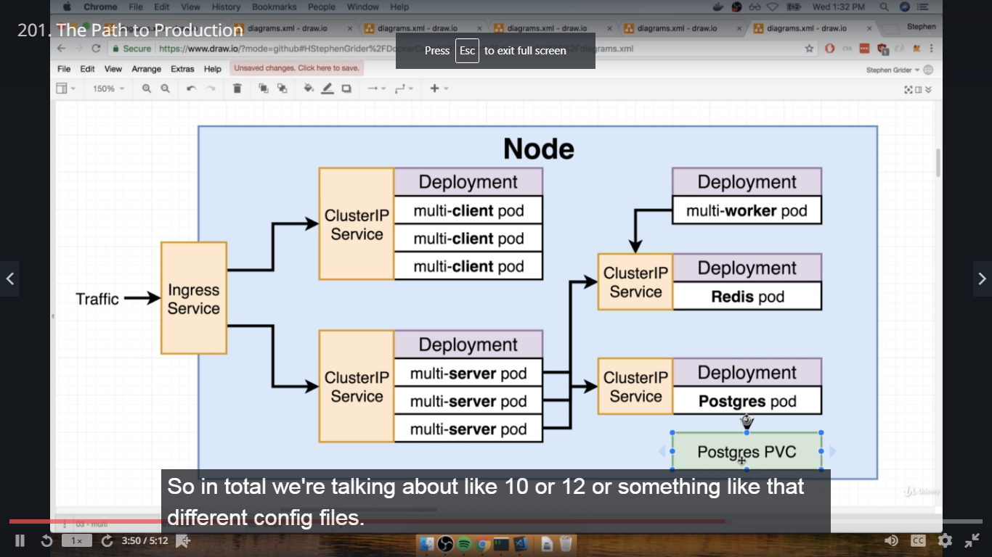

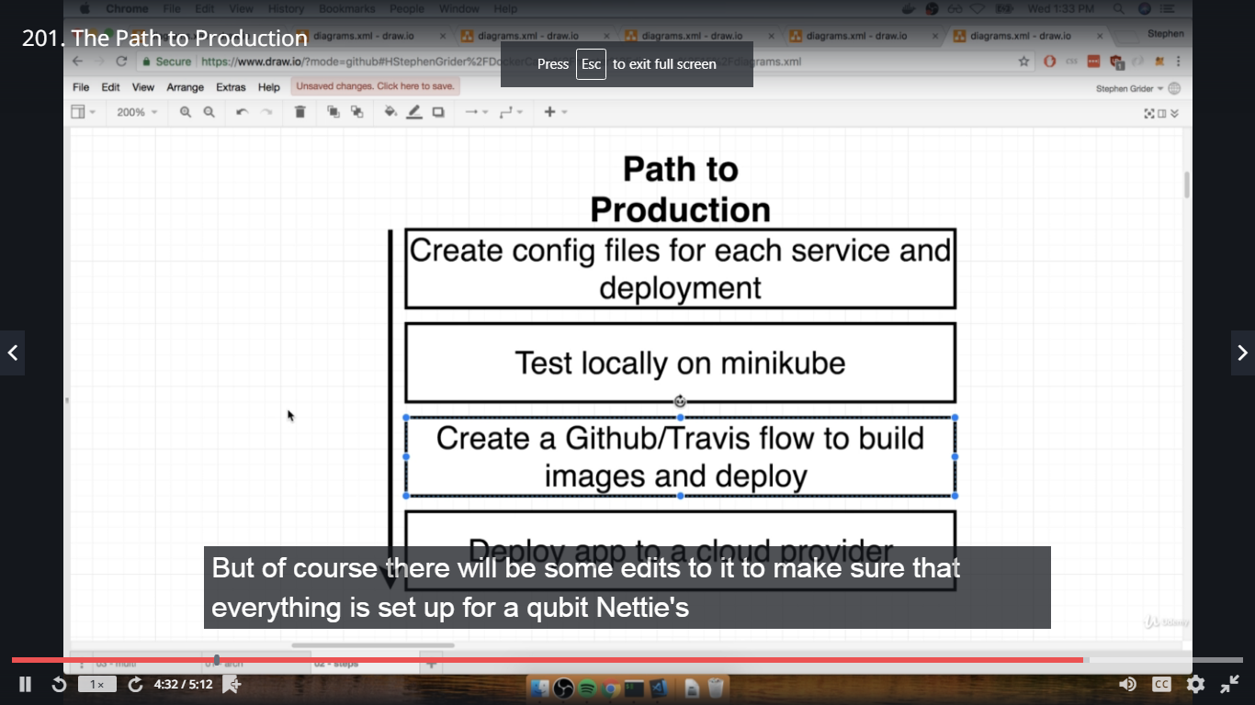

202. Checkpoint Files

Attached to this section is a ZIP file with the current state of my 'complex' multi-container project. If you made any changes to your copy of the multi-container project, or if you didn't get it working, then download this zip file and use my copy.

Its extremely important that your project files are identical to mine at this point - if anything is different then a lot of the Kubernetes stuff is going to appear to just not "work" for some mysterious reason.

Resources for this lecture

complex.zip

203. A Quick Checkpoint

In terminal complex dir,

#ls

#docker ps

#docker-compose up --build

#docker-compose up ------ since 1st time it will crash, do it 2nd time

In complex dir-->docker-compose.yml file ---- check ports

In browser-localhost:3050 ------ react app of fib calculator

204. Recreating the Deployment --- Back up complex folder before doing the below

In terminal root dir-->complex-->#code .

Delete travis.yml, docker-compose.yml, Dockerrun.aws.json files and nginx folder from complex dir.

Create k8s folder in complex dir and create client-deployment.yaml in k8s folder,

kpiVersion: apps/v1

Kind: Deployment

metadata:

name: client-deployment

spec:

replicas: 3

selector:

matchLabels:

component: web

template:

metadata:

label:

component: web

spec:

containers:

- name: client

image: dockeruserid/multi-client

ports:

- containerPort: 3000

205. NodePort vs ClusterIP Services

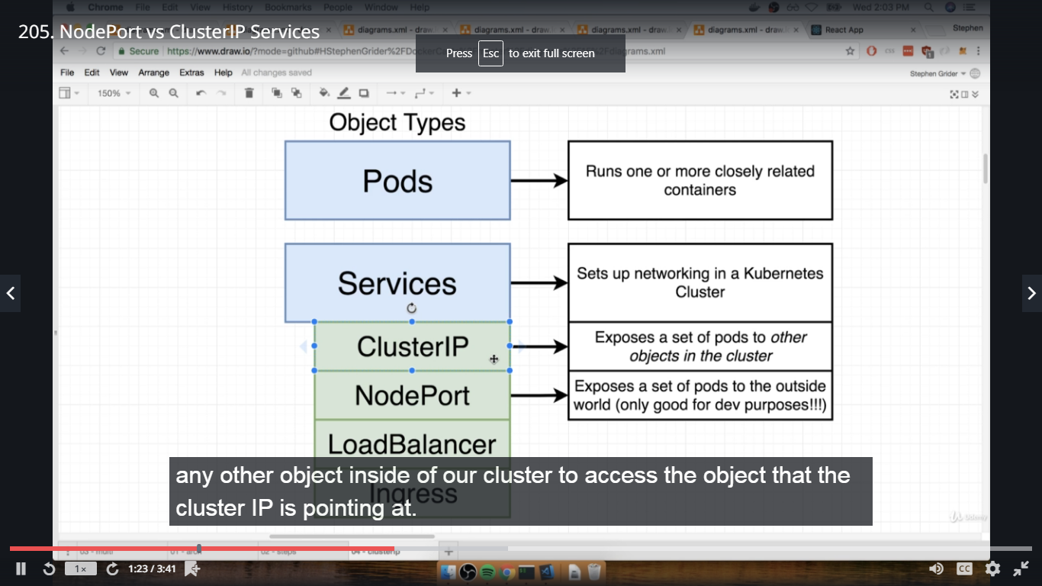

206. The ClusterIP Config

Create client-cluster-ip-service.yaml file in k8s dir,

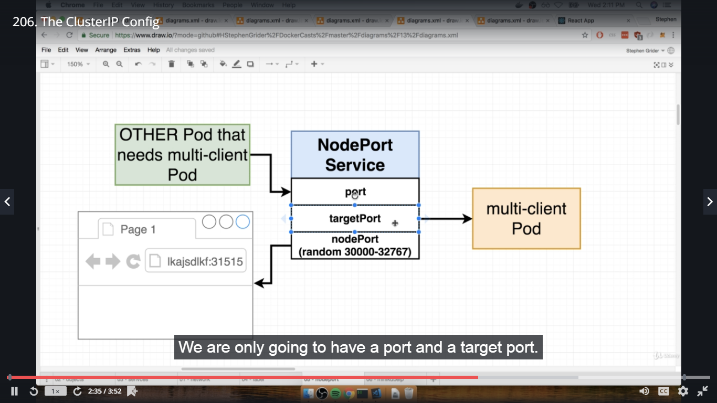

apiVersion: v1

kind: Service

metadata:

name: client-cluster-ip-service

spec:

type: ClusterIP

selector:

component: web

ports:

- port: 3000

targetPort: 3000

207. Applying Multiple Files with Kubectl

In terminal complex dir, To delete old deployments,

#kubectl get deployments

#kubectl delete deployment client-deployment

#kubectl get services

#kubectl delete service client-node-port\ ----- to delete service which was accessed for cleint-deployment

#kubectl apply -f k8s/client-deployment.yaml

#ls

#kubectl apply -f k8s

#kubectl get deployments

#kubectl get pods

#kubectl get services

208. Express API Deployment Config

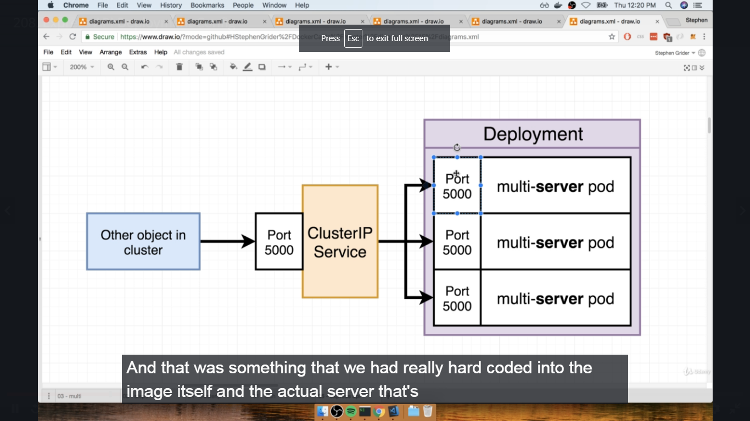

Create server-deployment.yaml file in k8s dir,

apiVersion: apps/v1

kind: Deployment

metadata:

name: server-deployment

spec:

replicas: 3

selector:

matchLabels:

component: server

template:

metadata:

labels:

component: server

spec:

containers:

- name: server

image: dockeruserid/multi-server

ports:

- containerPort: 5000

209. Cluster IP for the Express API

Create server-cluster-ip-service.yaml file in k8s dir,

apiVersion: v1

kind: Service

metadata:

name: server-cluster-ip-service

spec:

type: ClusterIP

selector:

component: server

ports:

- port: 5000

targetPort: 5000

210. Combining Config into Single Files

Create server-config.yaml file in k8s dir,------ this file has been deleted as we have made separate files, this was only to show configuration in single file

apiVersion: apps/v1

kind: Deployment

metadata:

name: server-deployment

spec:

replicas: 3

selector:

matchLabels:

component: server

template:

metadata:

labes:

component: server

spec:

containers:

- name: server

image: dockeruserid/multi-server

ports:

- containerPort: 5000

---

apiVersion: v1

kind: Service

metadata:

name: server-cluster-ip-service

spec:

type: ClusterIP

selector:

component: server

ports:

- port: 5000

targetPort: 5000

211. The Worker Deployment

Create worker-deployment.yaml file in k8s dir,

apiVersion: apps/v1

kind: Deployment

metadata:

name: worker-deployment

spec:

replicas: 1

selector:

matchLabels:

component: worker

template:

metadata:

labels:

component: worker

spec:

containers:

- name: worker

image: dockeruserid/multi-worker

212. Reapplying a Batch of Config Files

In terminal complex dir,

#ls

#ls k8

#kubectl apply -f k8s --- all config files considered in k8s folder

#kubectl get pods

#kubectl get deployments

#kubectl get services

#kubectl logs pod_name

213. Creating and Applying Redis

Create redis-deployment.yaml file in k8s dir,

apiVersion: apps/v1

kind: Deployment

metadata:

name: redis-deployment

spec:

replicas: 1

selector:

matchLabels:

component: redis

template:

metadata:

labels:

component: redis

spec:

containers:

- name: redis

image: redis

ports:

- containerPort: 6379

Create redis-cluster-ip-service.yaml file in k8s dir,

apiVersion: v1

kind: Service

metadata:

name: redis-cluster-ip-service

spec:

type: ClusterIP

selector:

component: redis

ports:

- port: 6379

targetPort: 6379

In terminal complex dir,

#ls

#kubectl apply -f k8s

#kubectl get pods

#kubectl get services

214. Last Set of Boring Config

Create postgres-deployment.yaml file in k8s dir,

apiVersion: apps/v1

kind: Deployment

metadata:

name: postgres-deployment

spec:

replicas: 1

selector:

matchLabels:

component: postgres

template:

metadata:

labels:

component: postgres

spec:

containers:

- name: postgres

image: postgres

ports:

- containerPort: 5432 ---- default port for postgres

Create postgres-cluster-ip-service.yaml file in k8s dir,

apiVersion: v1

kind: Service

metadata:

name: postgres-cluster-ip-service

spec:

type: ClusterIP

selector:

component: postgres

ports:

- port: 5432

targetPort: 5432

In terminal complex dir,

#ls

#kubectl apply -f k8s

#kubectl get pods

215. The Need for Volumes with Databases

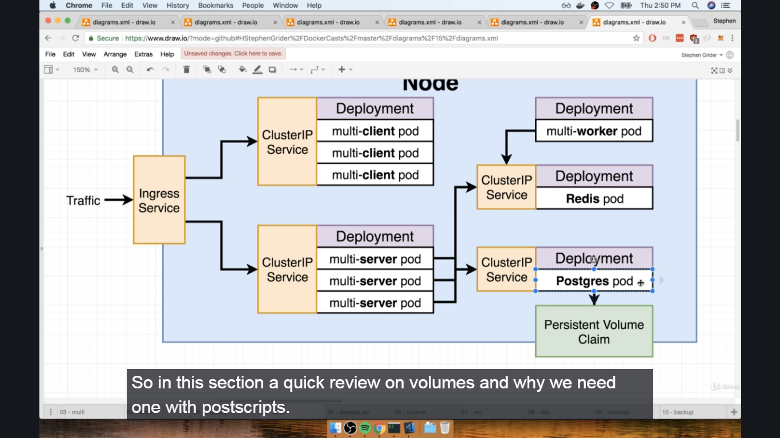

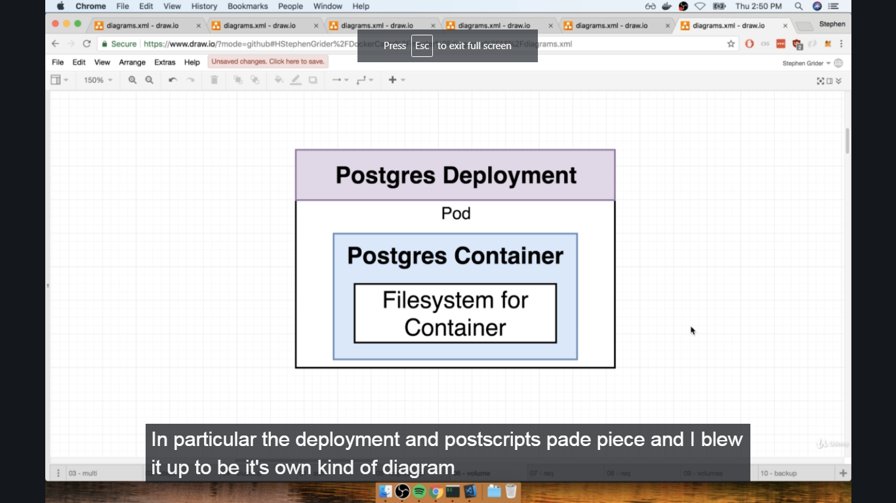

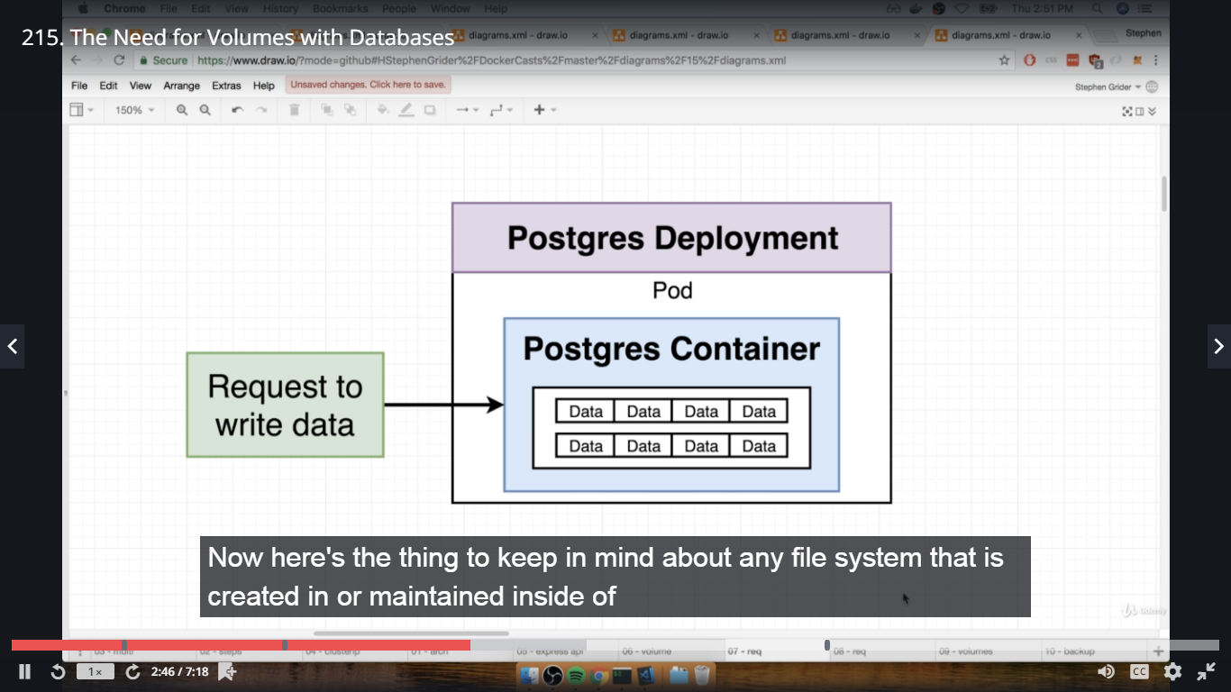

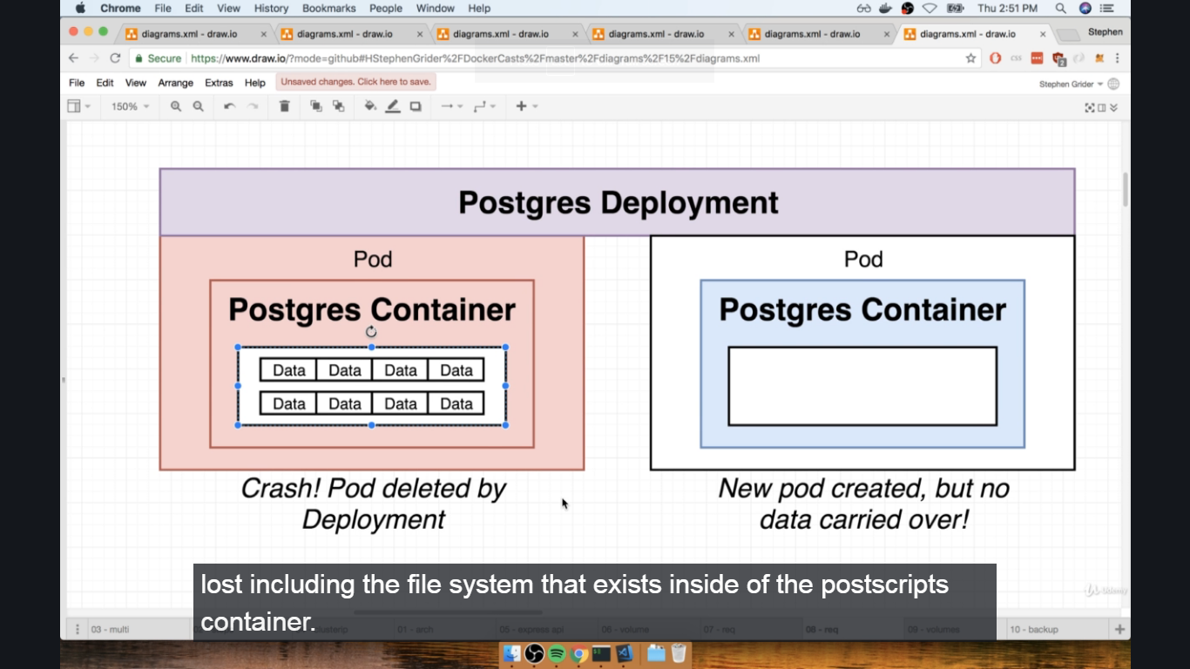

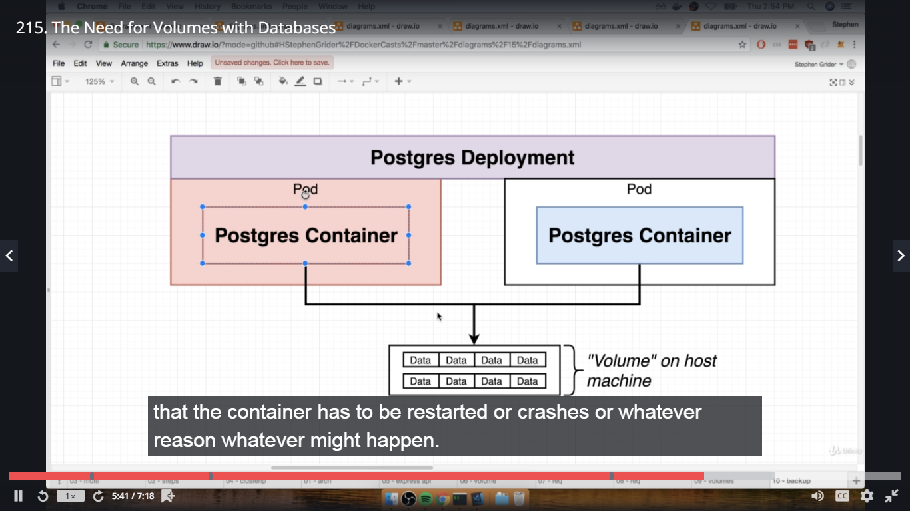

216. Kubernetes Volumes

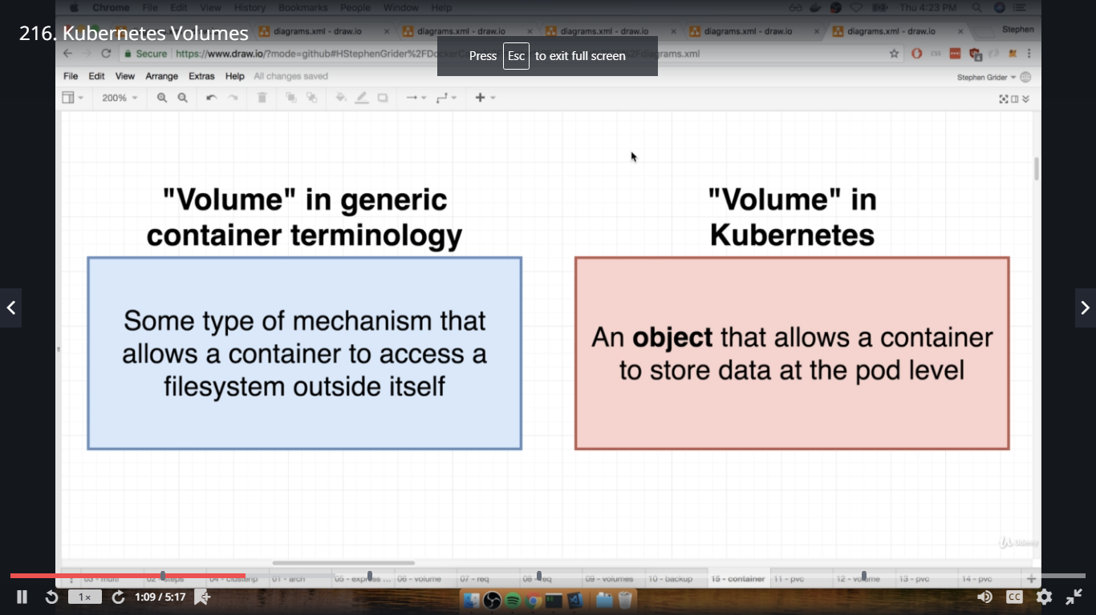

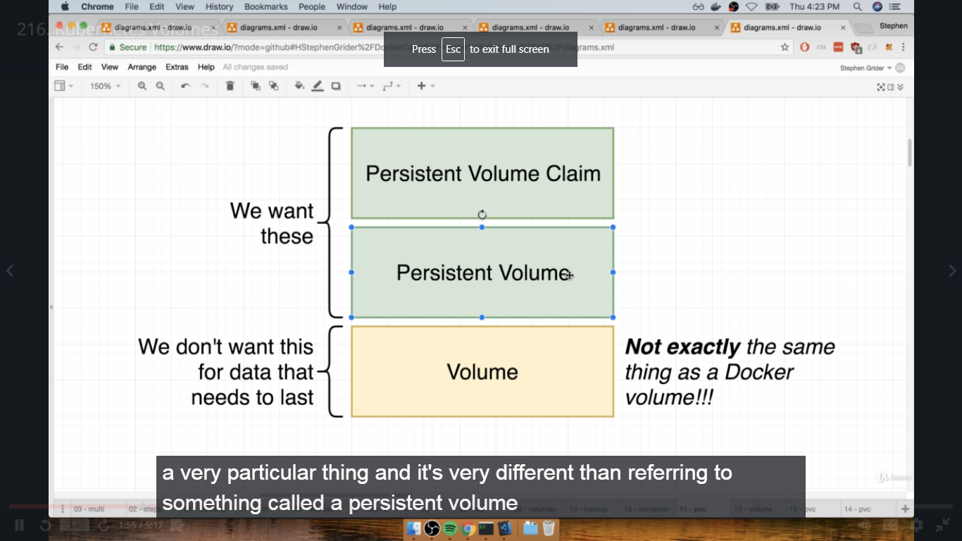

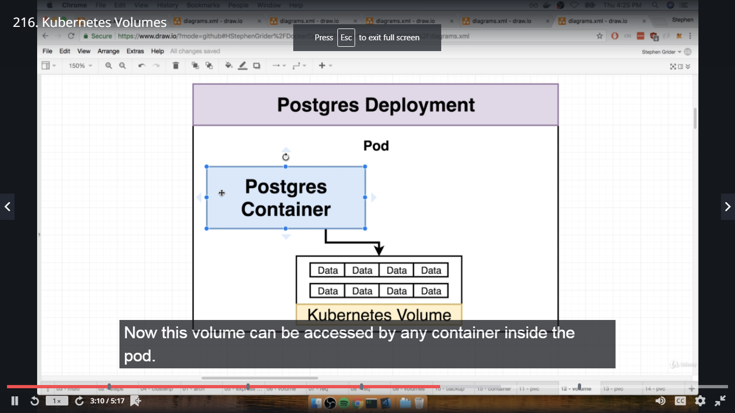

217. Volumes VS Persistent Volumes

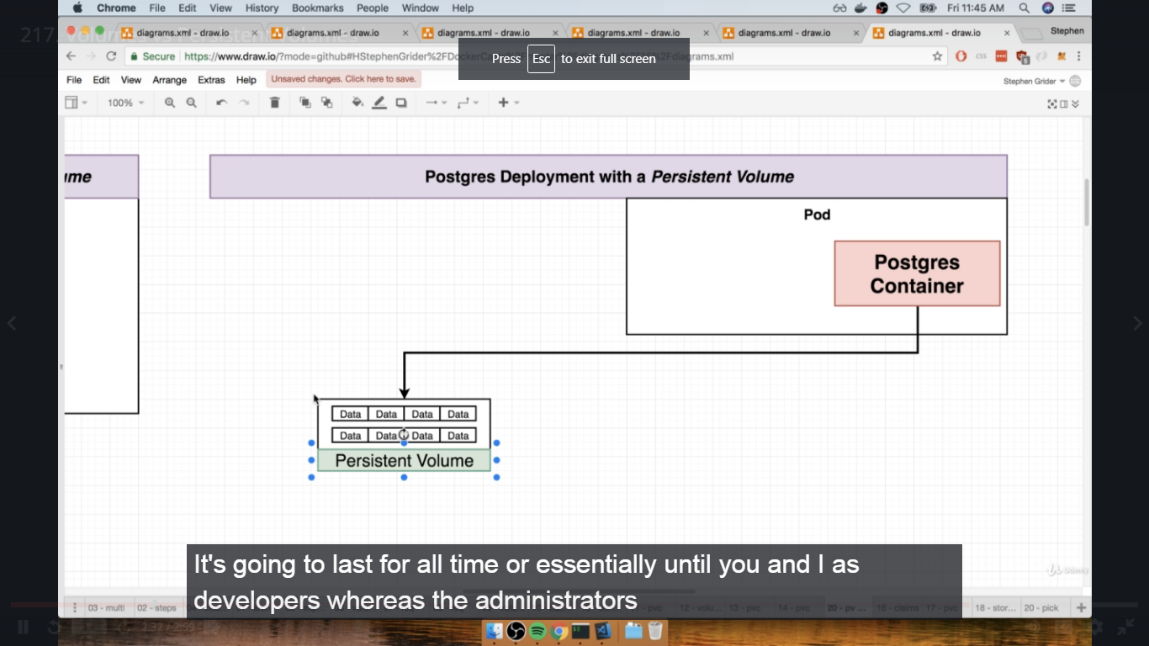

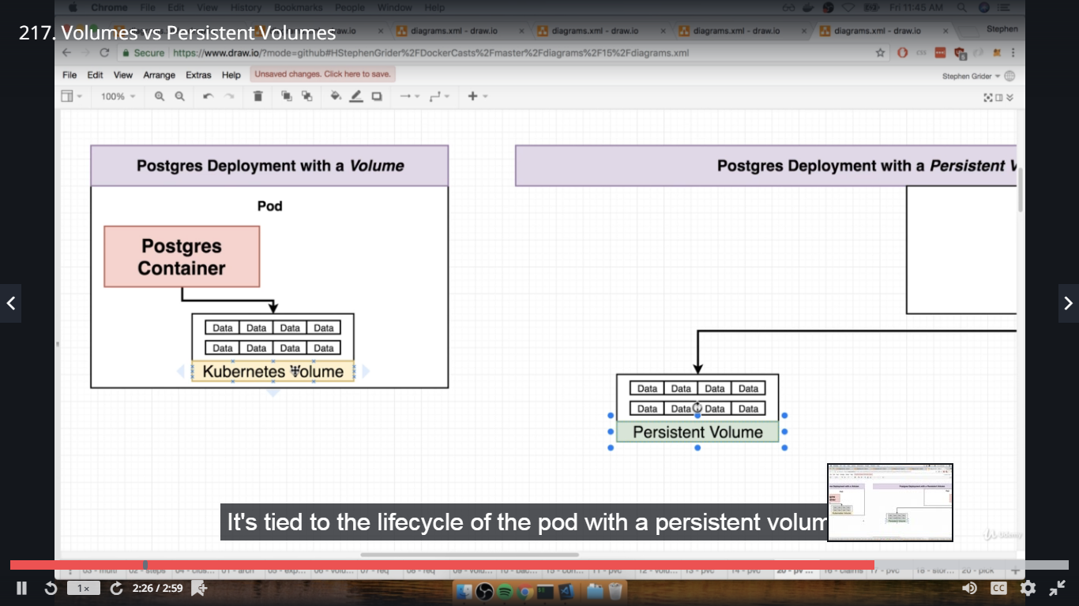

Normal Volumes refer to data stored in the pod and once pod crashes, all data tied to it will be gone.

Persistent Volumes refers to data stored outside the pod and is persistently stored so if pod crashes also then too another pod will be created and it will be tied to the data stored outside pod.

218. Persistent Volumes Vs Persistent Volumes Claim

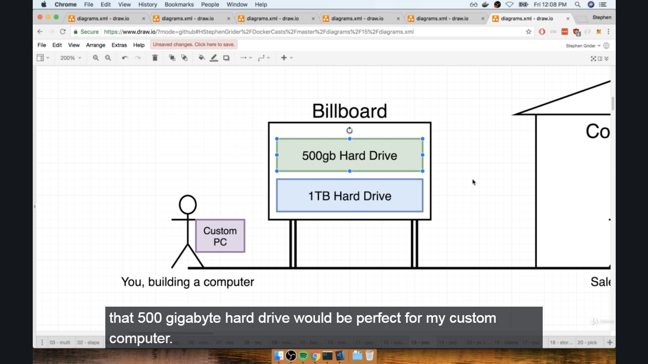

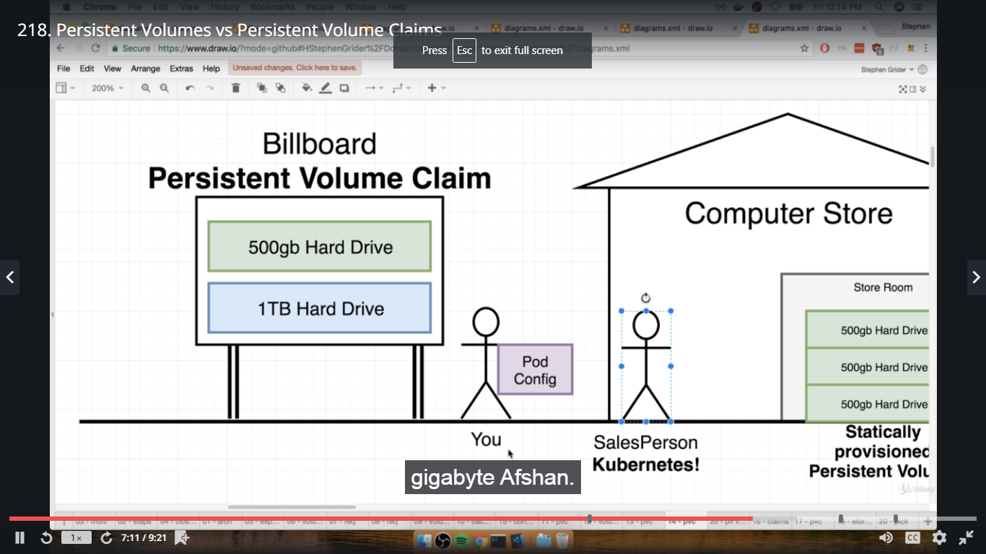

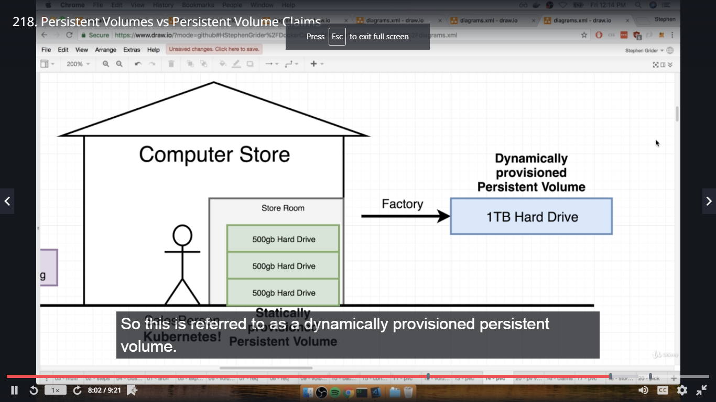

219. Claim Config Files

Create database-persistent-volume-claim.yaml in k8s dir

apiVersion: v1

kind: PersisteVolumeClaim

metadata:

name: database-persistent-volume-claim

spec:

accessModes:

- ReadWriteOnce

resources:

requests:

storage: 2Gi

220. Persistent Volume Access Modes

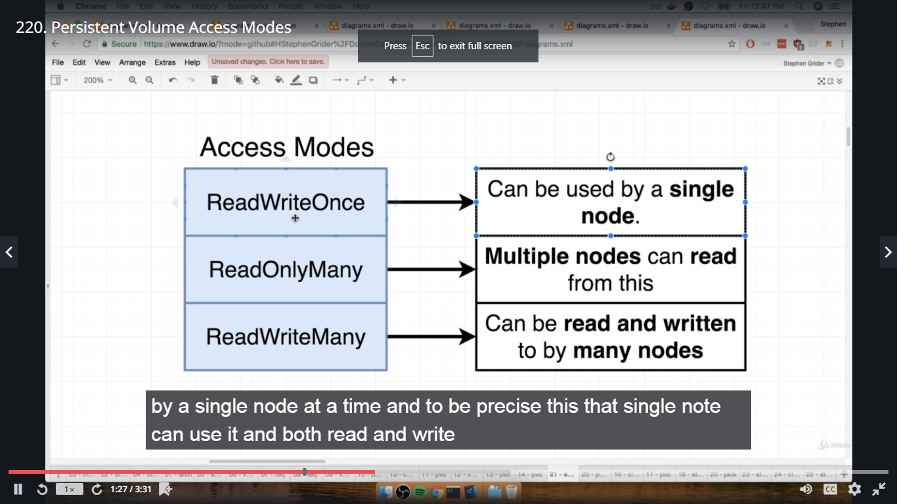

221. Where Does Kubernetes Allocate Persistent Volumes?

#kubectl get storageclass ---- standard is default

#kubectl describe storageclass

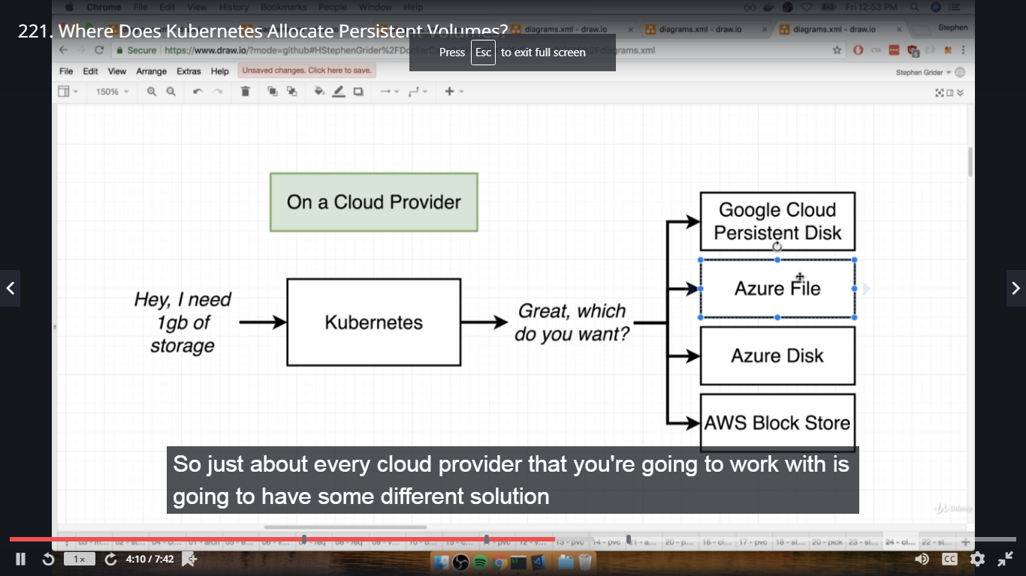

222. Designating a PVC in a Pod Template

Some changes in postgres-deployment.yaml file in k8s dir,

apiVersion: apps/v1

kind: Deployment

metadata:

name: postgres-deployment

spec:

replicas: 1

selector:

matchLabels:

component: postgres

template:

metadata:

labels:

component: postgres

spec:

volumes:

- name: postgres-storage

persistentVolumeClaim:

claimName: database-persistent-volume-claim

containers:

- name: postgres

image: postgres

ports:

- containerPort: 5432

volumeMounts:

- name: postgres-storage

mountPath: /var/lib/postgresql/data

subPath: postgres

223. Fix for Postgres CrashLoopBackOff Error on Windows Pro

This note is only for students that are on Windows Pro and are using Docker Desktop's built-in Kubernetes. If you are using Docker for Mac's Kubernetes or Minikube this issue will not apply to you and can be skipped.

In the next lecture, we will be running a kubectl apply -f k8s after creating our PersistentVolumeClaim. You will likely notice that your Postgres pod will show a status of CrashLoopBack.

To resolve this we need to create a PersistentVolume in addition to the PersistentVolumeClaim.

You can refer to the official Kubernetes docs here:

https://kubernetes.io/docs/tasks/configure-pod-container/configure-persistent-volume-storage/

1. Create a database-persistent-volume.yaml and enter the following:

kind: PersistentVolume

apiVersion: v1

metadata:

name: database-persistent-volume

labels:

type: local

spec:

storageClassName: manual

capacity:

storage: 2Gi

accessModes:

- ReadWriteOnce

hostPath:

path: "/mnt"

The docs specify that you should SSH into the node and create a data directory under /mnt but we could similarly just specify /mnt or as another student mentioned /tmp as the hostPath

2. Create the database-persistent-volume-claim.yaml file:

kind: PersistentVolumeClaim

apiVersion: v1

metadata:

name: database-persistent-volume-claim

spec:

storageClassName: manual

accessModes:

- ReadWriteOnce

resources:

requests:

storage: 2Gi

This is pretty similar to what is used in the course, except that we are adding 'storageClassName' which binds PersistentVolumeClaim requests to the PersistentVolume.

3. Run kubectl apply -f k8s

4. Run kubectl get pods and the postgres pod should show a status of Running

224. Applying a PVC

In complex dir,

#ls

#kubectl apply -f k8s

#kubectl get pv

#kubectl get pvc

225. Defining Environment Variables

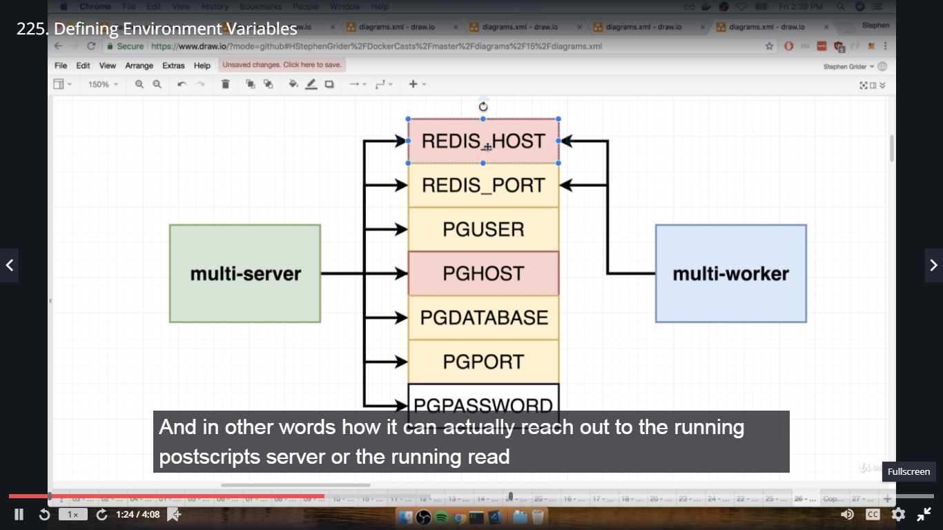

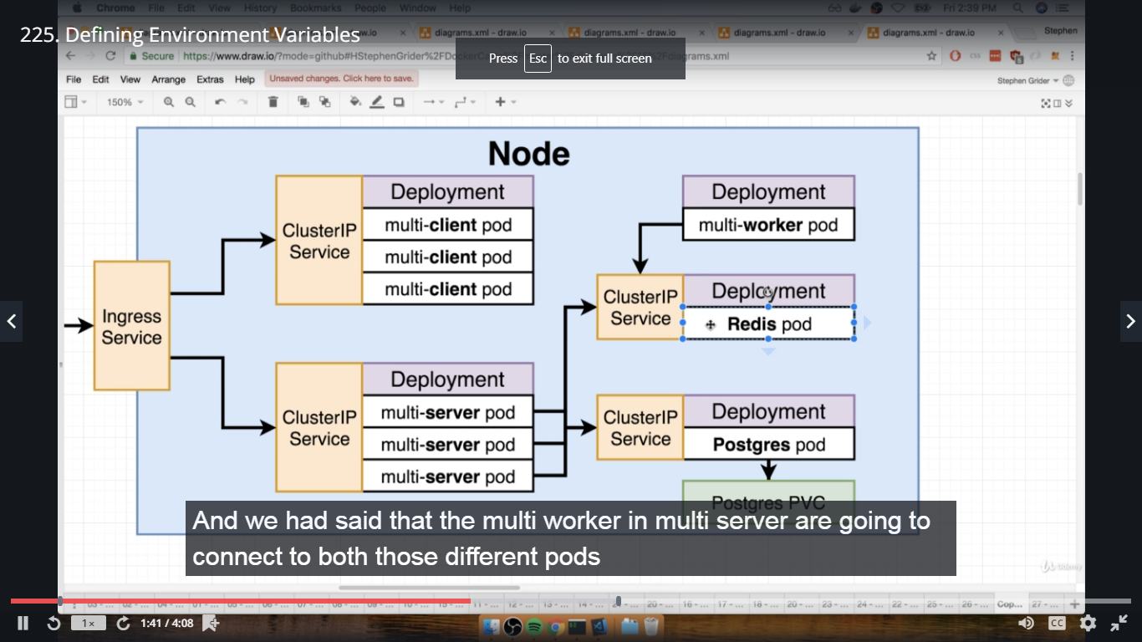

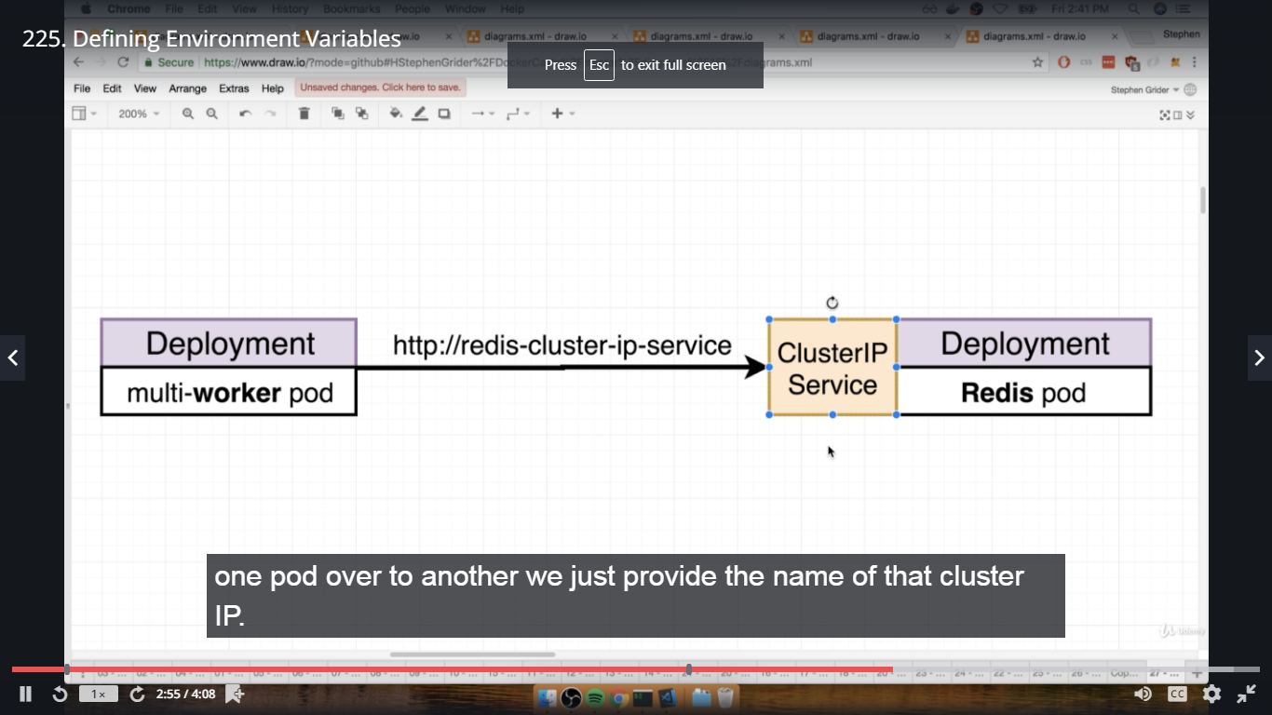

226. Adding Environment Variables to Config

adding env variable in worker-deployment.yaml file in k8s dir,

apiVersion: apps/v1

kind: Deployment

metadata:

name: worker-deployment

spec:

replicas: 1

selector:

matchLabels:

component: worker

template:

metadata:

labels:

component: worker

spec:

containers:

- name: worker

image: dockeruserid/multi-worker

env:

- name: REDIS_HOST

value: redis-cluster-ip-service

- name: REDIS_PORT

value: 6379

adding env variables in server-deployment.yaml file in k8s dir,

apiVersion: apps/v1

kind: Deployment

metadata:

name: server-deployment

spec:

replicas: 3

selector:

matchLabels:

component: server

template:

metadata:

labels:

component: server

spec:

containers:

- name: server

image: dockeruserid/multi-server

ports:

- containerPort: 5000

env:

- name: REDIS_HOST

value: redis-cluster-ip-service

- name: REDIS_PORT

value: 6379

- name: PGUSER

value: postgres

- name: PGHOST

value: postgres-cluster-ip-service

- name: PGPORT

value: 5432

- name: PGDATABASE

value: postgres

227. Creating an Encoded Secret

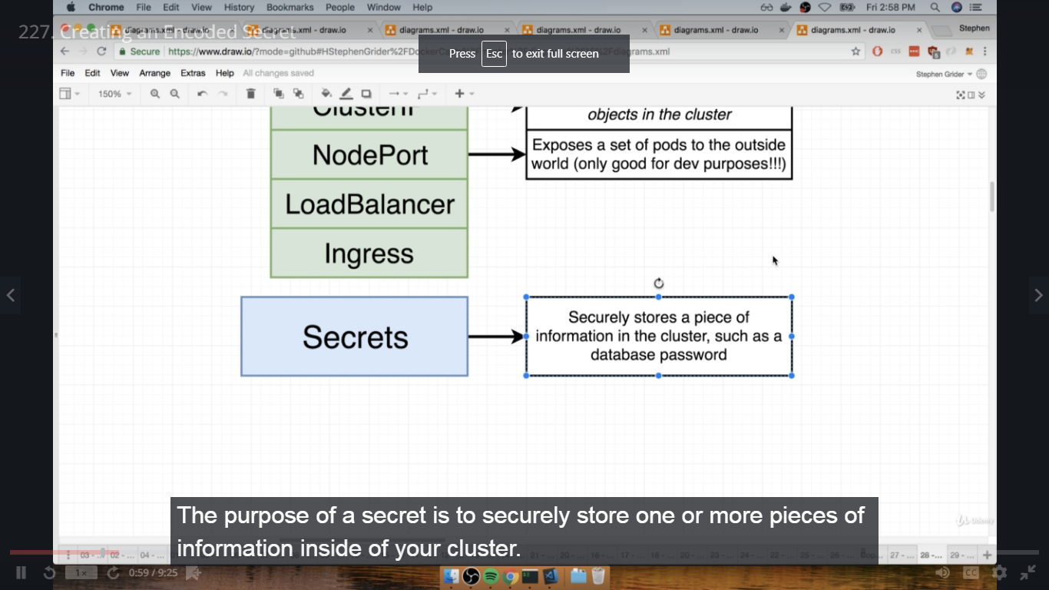

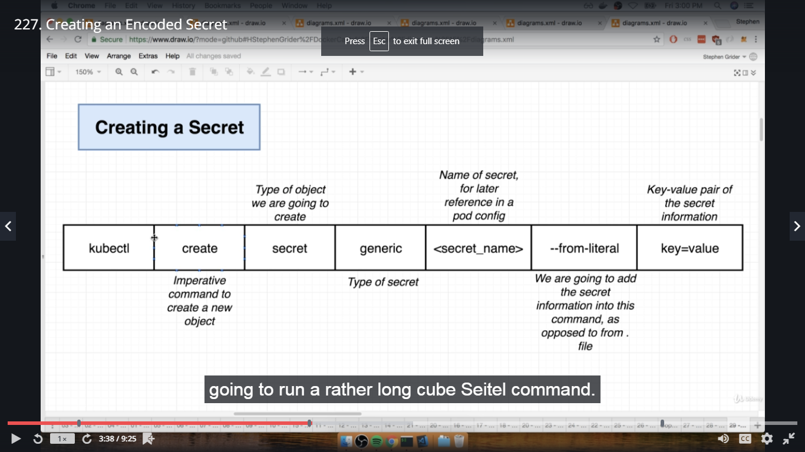

In terminal complex dir,

#kubectl create secret generic pgpassword --from-literal PGPASSWORD=12345asdf

#kubectl get secrets

228. Passing Secrets as Environment Variables

Add pgpassword at last in server-deployment.yaml file in k8s dir,

- name: PGPASSWORD

valueFrom:

secretKeyRef:

name: pgpassword

key: PGPASSWORD

Add env in postgres-deployment.yaml file in k8s dir,

add at Last under containers:

env:

- name:PGPASSWORD

valueFrom:

secretKeyRef:

name: pgpassword

key: PGPASSWORD

In terminal complex dir,

#kubectl apply -f k8s ----- error msg as cannot convert int64 to string

229. Environment Variables as Strings

In server-deployment.yaml and worker-deployment.yaml file, port values are given as integer, to avoid the above error we will put port values into single quote' ' and save the files.

In terminal complex dir,

#kubectl apply -f k8s

Section 15: Handling Traffic with Ingress Controllers

230. Load Balancer Services

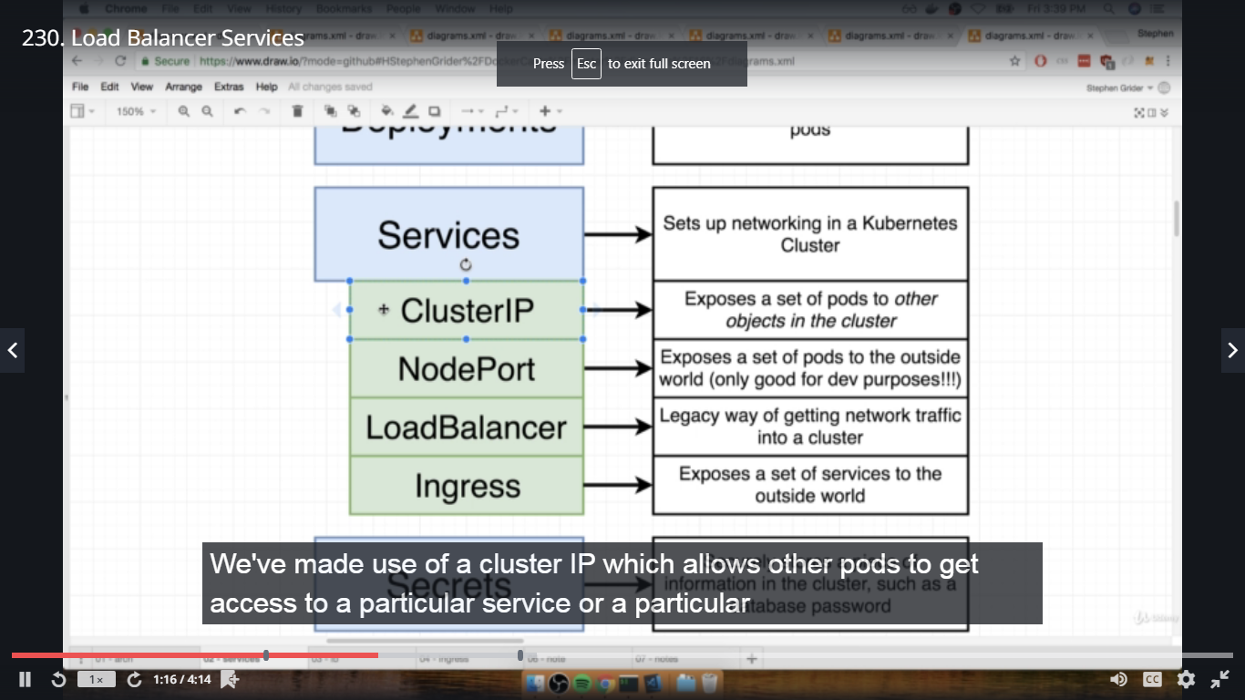

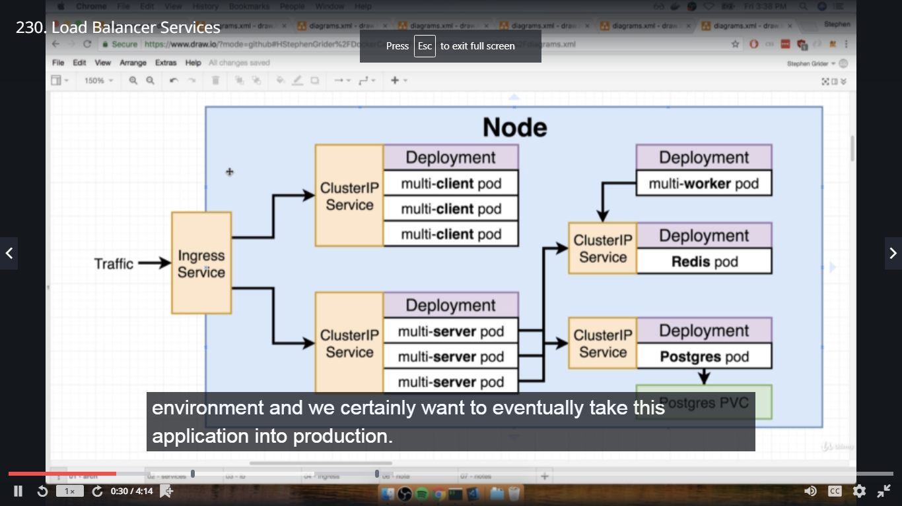

231. A Quick Note on Ingresses

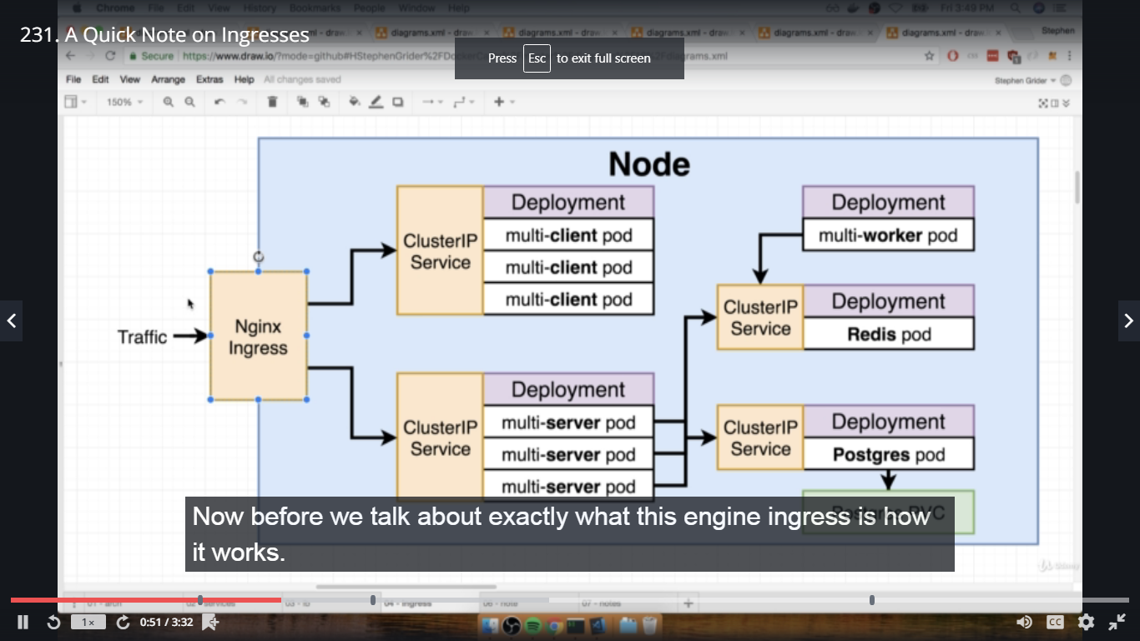

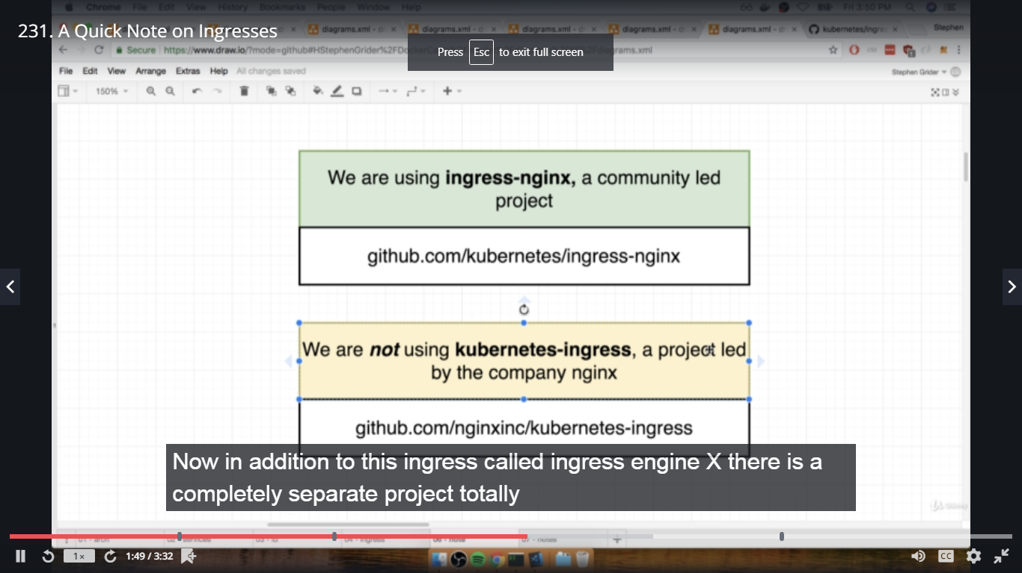

232. One Other Quick Note!

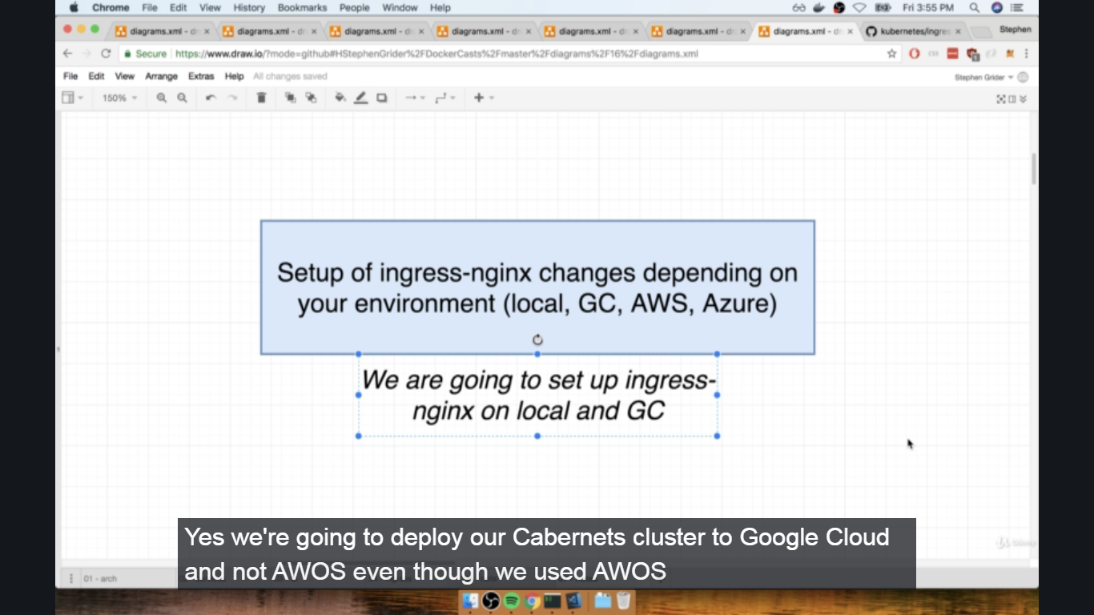

233. Behind the Scenes of Ingress

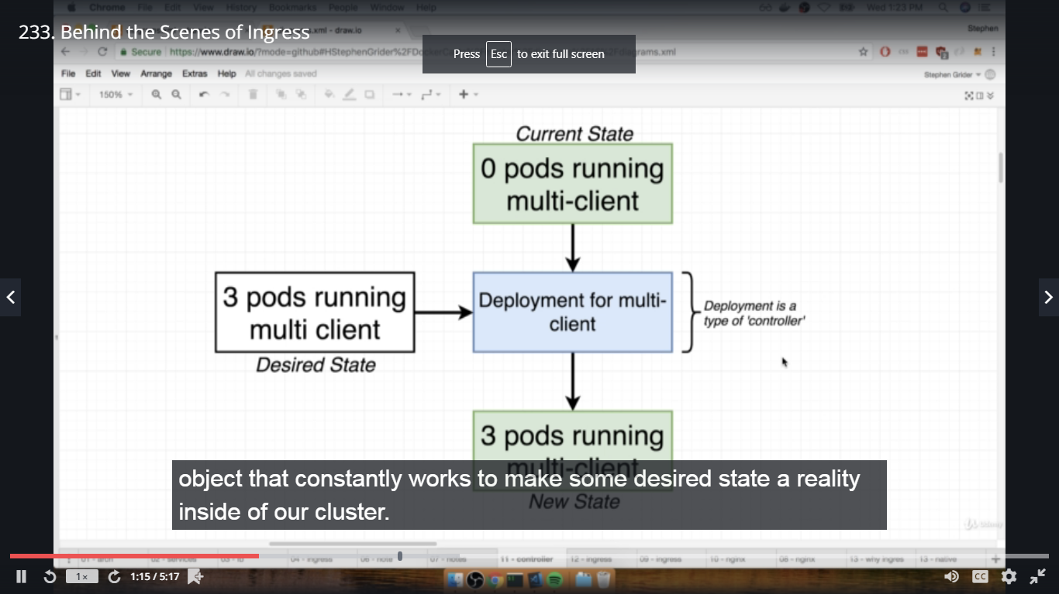

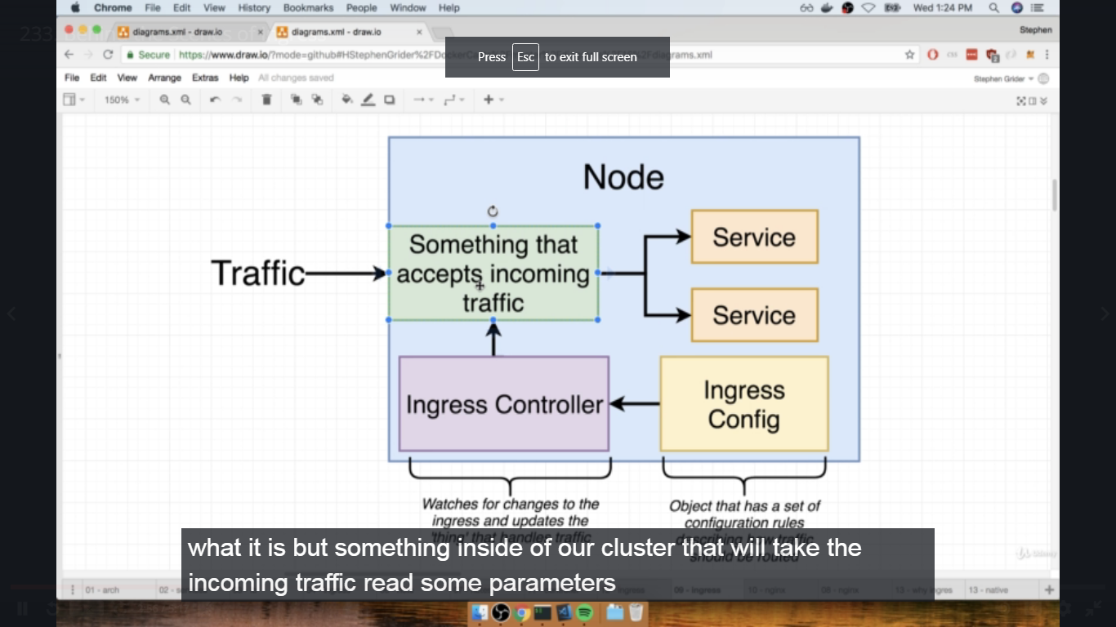

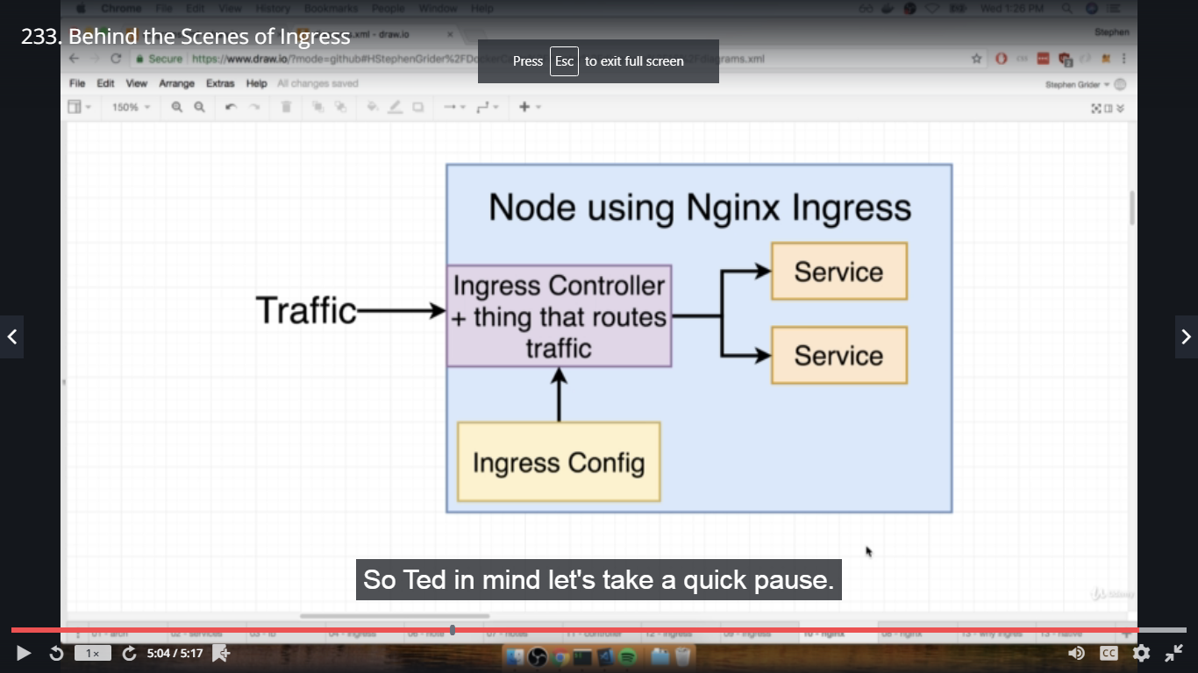

234. More Behind the Scenes of Ingress

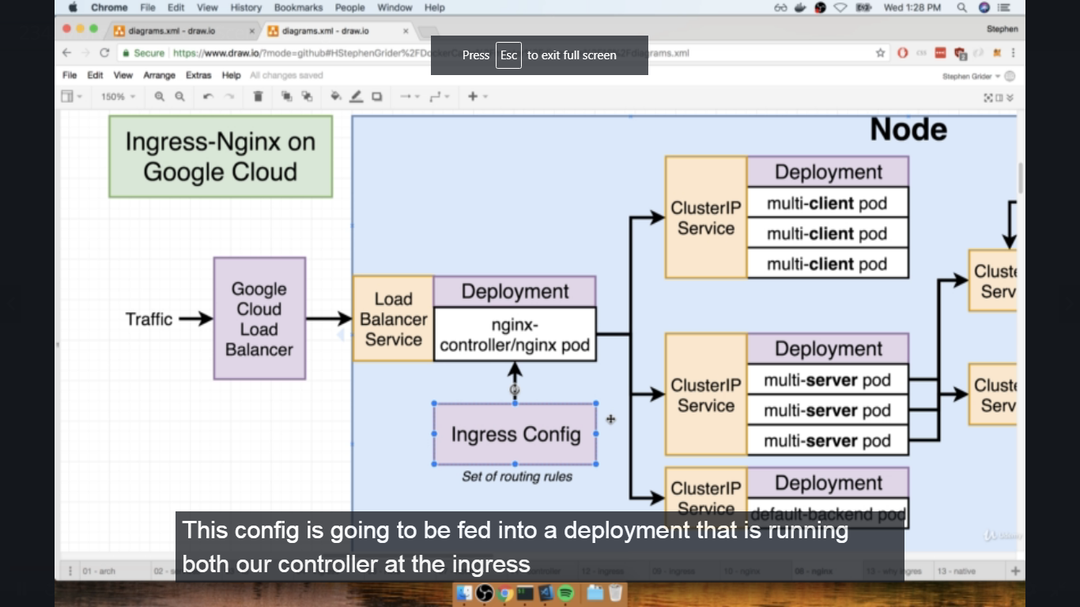

235. Optional Reading on Ingress Nginx

Just in case you wanted to understand ingress-nginx a bit better, check out this article by Hongli Lai - https://www.joyfulbikeshedding.com/blog/2018-03-26-studying-the-kubernetes-ingress-system.html. Hongli is an absolute genius, he co-created Phusion Passenger, an extremely popular webserver that integrates with Nginx.

236. Setting up Ingress Locally with Minikube

Browse github.com/kubernetes/ingress-nginx----Click on same link and in home page, click on Deployment tab for Installation guide

-Generic Deployment

execute mandatory command in terminal, first copy the link and paste in another browser tab-config file will open

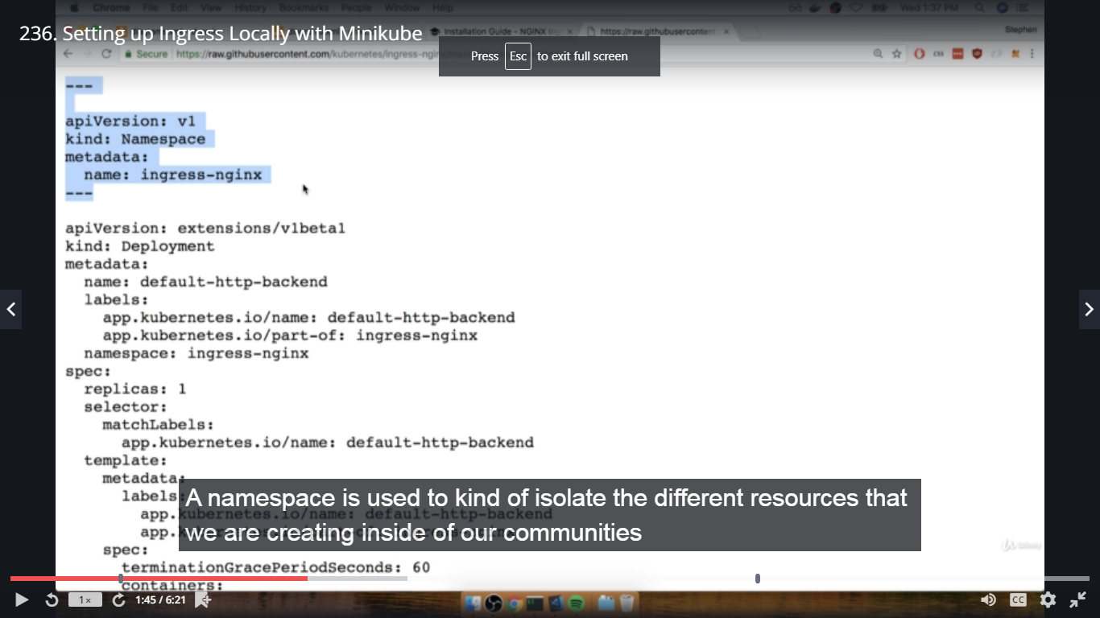

Now in terminal complex dir, paste the copied cmd and execute

#kubectl apply -f https://

Then copy cmd of minikube for standard usage

#minikube addons enable ingress

237. Setting up Ingress with Docker Desktop's Kubernetes

This note is only for students that are using Docker Desktop's built-in Kubernetes. If you are using Minikube, this section does not apply to and can be skipped.

In the previous lecture we learned how to setup and enable Ingress for Minikube. If you are using Docker Desktop's Kubernetes, the second step to enable the service is a little different.

1. Make sure you executed the mandatory generic script that was discussed in the lecture:

kubectl apply -f https://raw.githubusercontent.com/kubernetes/ingress-nginx/master/deploy/static/mandatory.yaml

2. Execute the provider specific script to enable the service:

kubectl apply -f https://raw.githubusercontent.com/kubernetes/ingress-nginx/master/deploy/static/provider/cloud-generic.yaml

The official docs are not very clear about this but the script applies to both Windows and Mac versions of Docker Desktop, even though it only lists Docker for Mac. If you have missed this step, then your Ingress will not work!

3. Verify the service was enabled by running the following:

kubectl get svc -n ingress-nginx

238. Creating the Ingress Configuration

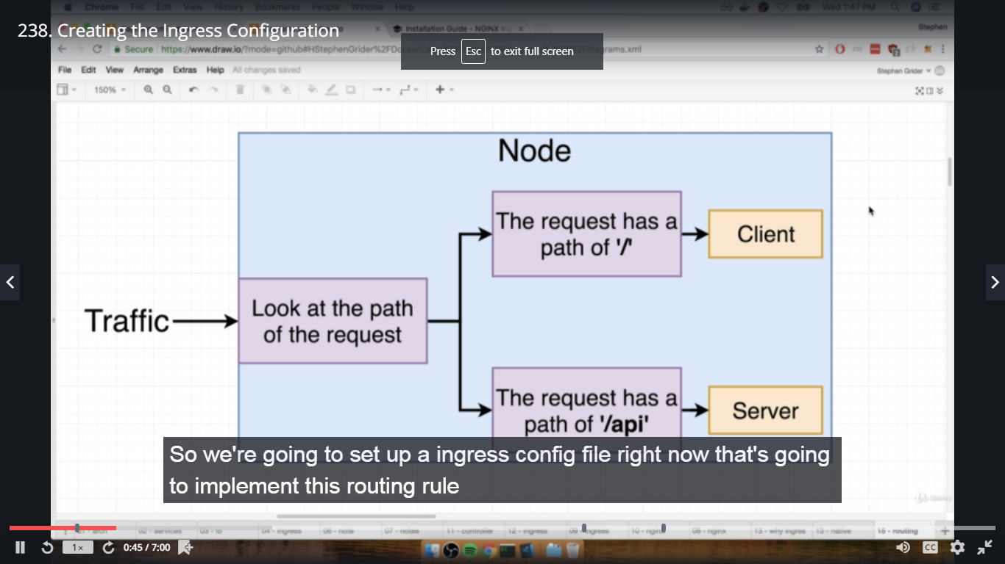

Create ingress-service.yaml file in k8s dir,

apiVersion: extensions/v1beta1

kind: Ingress

metadata:

name: ingress-service

annotations:

kubernetes.io/ingress.class: nginx

nginx.ingress.kubernetes.io/rewrite-target: / ---- how will nginx behaves

spec:

rules:

- http:

paths:

- path: /

backend:

serviceName: client-cluster-ip-service

servicePort: 3000

- path: /api/

backend:

serviceName: server-cluster-ip-service

servicePort: 5000

In terminal complex dir,

#ls

#kubectl apply -f k8s ---- ingress-service created

239. Fix for ingress-service.yaml Configuration

In the previous lecture we created our ingress-service.yaml configuration file. There has recently been an update to how we need to specify some of these rules.

Three lines need to be changed - the annotation of rewrite-target and the two path identifiers:

apiVersion: extensions/v1beta1

kind: Ingress

metadata:

name: ingress-service

annotations:

kubernetes.io/ingress.class: nginx

nginx.ingress.kubernetes.io/rewrite-target: /$1

# UPDATE THIS LINE ABOVE

spec:

rules:

- http:

paths:

- path: /?(.*)

# UPDATE THIS LINE ABOVE

backend:

serviceName: client-cluster-ip-service

servicePort: 3000

- path: /api/?(.*)

# UPDATE THIS LINE ABOVE

backend:

serviceName: server-cluster-ip-service

servicePort: 5000

240. Testing Ingress Locally

In terminal complex dir,

#minikube ip

In browser, https://ip ----- fib calculator app

241. The Minikube Dashboard

In terminal complex dir,

#minikube dashboard ---- will open kubernetes dashboard in browser

visit every option and check yourself

242. Docker Desktop's Kubernetes Dashboard

This note is for students using Docker Desktop's built-in Kubernetes. If you are using Minikube, the setup here does not apply to you and can be skipped.

If you are using Docker Desktop's built-in Kubernetes, setting up the admin dashboard is going to take a little more work.

1. Grab the kubectl script we need to apply from the GitHub repository: <https://github.com/kubernetes/dashboard>

2. We will need to download the config file locally so we can edit it (make sure you are copying the most current version from the repo).

If on Mac or using GitBash on Windows enter the following:

curl -O https://raw.githubusercontent.com/kubernetes/dashboard/v1.10.1/src/deploy/recommended/kubernetes-dashboard.yaml

If using PowerShell:

Invoke-RestMethod -Uri https://raw.githubusercontent.com/kubernetes/dashboard/v1.10.1/src/deploy/recommended/kubernetes-dashboard.yaml -Outfile kubernetes-dashboard.yaml

3. Open up the downloaded file in your code editor and find line 116. Add the following two lines underneath --auto-generate-certificates:

1. args:
2. - --auto-generate-certificates
3. - --enable-skip-login
4. - --disable-settings-authorizer

4. Run the following command inside the directory where you downloaded the dashboard yaml file a few steps ago:

kubectl apply -f kubernetes-dashboard.yaml

5. Start the server by running the following command:

kubectl proxy

6. You can now access the dashboard by visiting:

http://localhost:8001/api/v1/namespaces/kube-system/services/https:kubernetes-dashboard:/proxy/

7. You will be presented with a login screen:

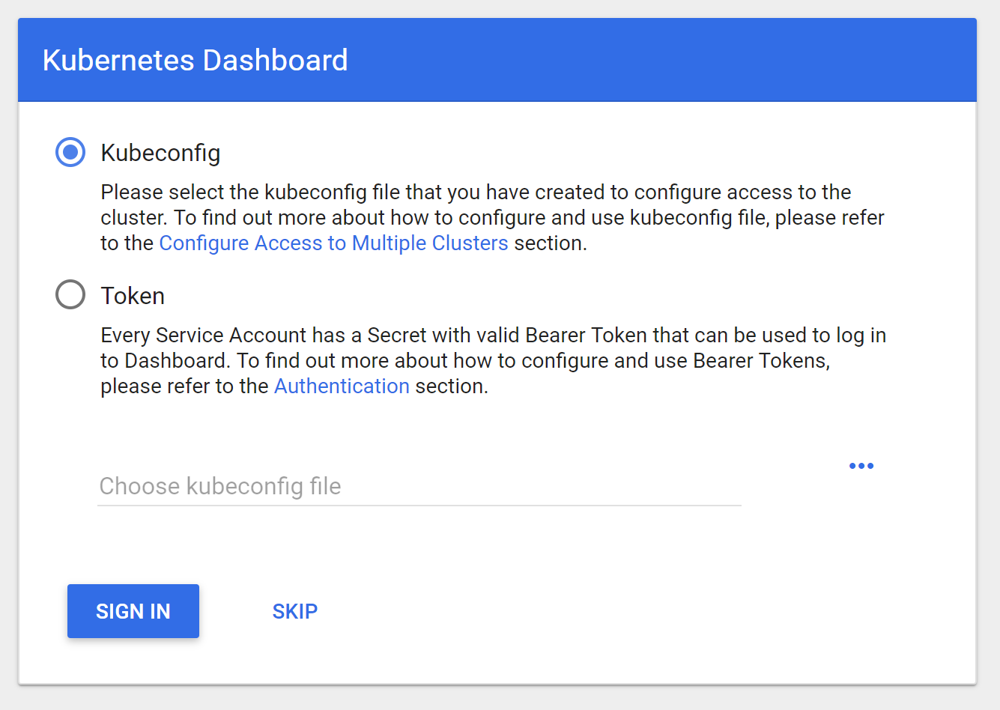

8. Click the "SKIP" link next to the SIGN IN button.

9. You should now be redirected to the Kubernetes Dashboard:

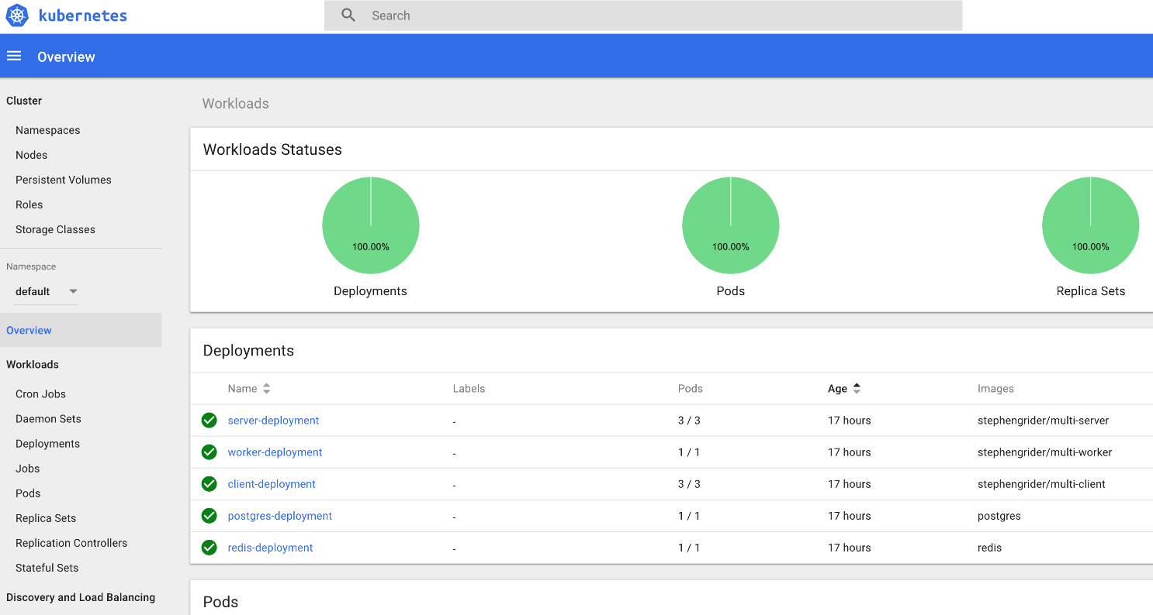

Important! The only reason we are bypassing RBAC Authorization to access the Kubernetes Dashboard is because we are running our cluster locally. You would never do this on a public facing server like Digital Ocean and would need to refer to the official docs to get the dashboard setup:  
<https://github.com/kubernetes/dashboard/wiki/Access-control>

Section 16: Kubernetes Production Deployment

243. The Deployment Process

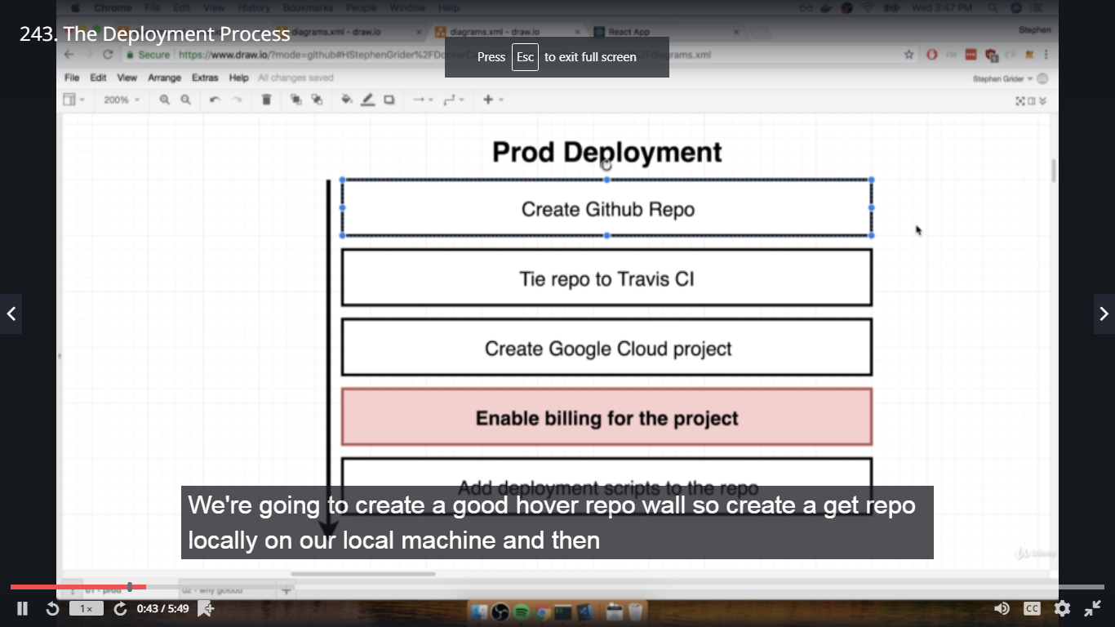

Here if we are using google cloud then we have to pay some amount, to check the price details browse google cloud cost calculator --- $42 per month

244. Google Cloud Vs AWS for Kubernetes

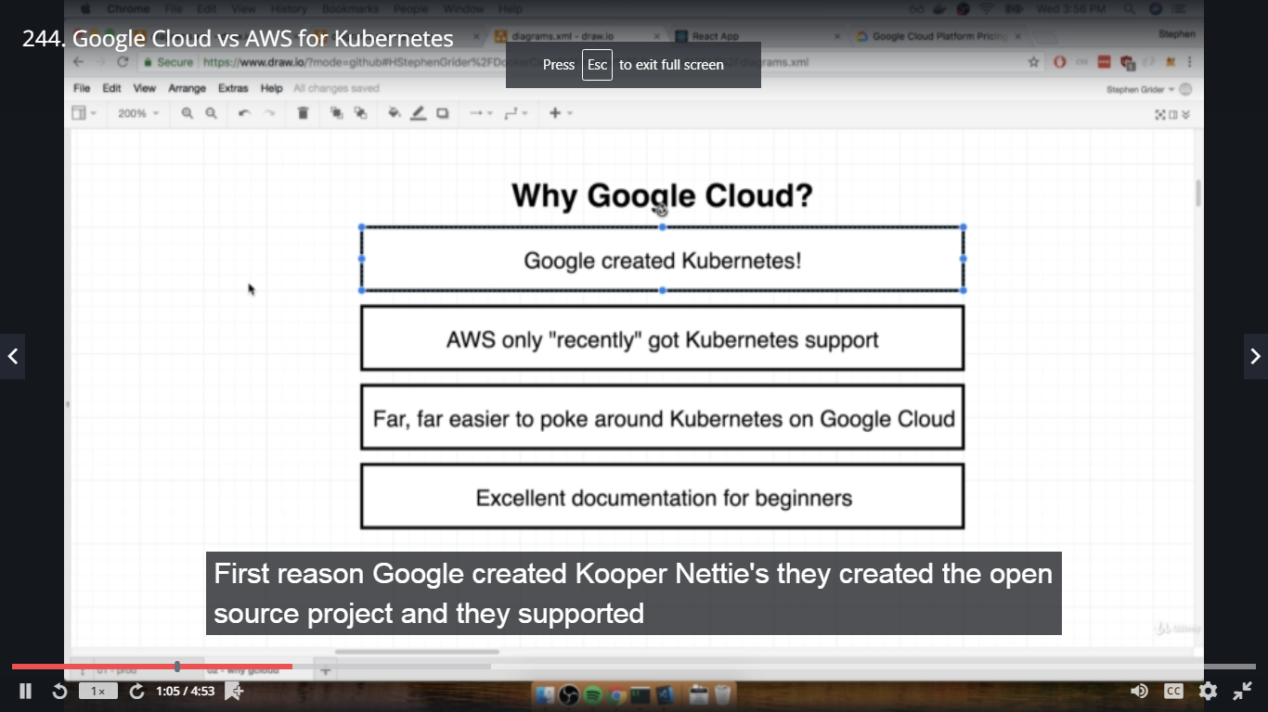

We can run same commands in google cloud as below

#kubectl get pods

245. Creating a Git Repo

Go to github.com-->create a new repo-->multi-k8s-->public and create repository

copy the git link

In terminal complex dir,

#ls -a ------ check .git is available or not

if not then, #git init ---- initialize git repo

if yes then, #git remote -v

#git remote remove origin ------- removing the old git initialization

After removing, add in the new git init,

#git remote add origin link.......

#git remote -v

#git push origin master

Check in github, all files pushed are available

246. Linking the Github Repo to Travis

Go to travis-ci.org--->LHS Sync Account--->Search multi-k8s in legacyservices Integration and

once found enable it to build

247. Free Google Cloud Credits

In the next section we are going to start creating our project on Google Cloud.

Remember, creating Kubernetes clusters on Google Cloud costs real money! If you are sensitive

to spending money, you can try getting some free Google Cloud credits using this link:

https://console.cloud.google.com/freetrial/signup/0. Note that if you already have a Google

Cloud account you will have to sign out of it and create a new account in order to get those

free credits.

248. Creating a Google Cloud Project

Google Cloud Console --- console.cloud.google.com

Create New Project-->multi-k8s

249. Linking a Billing Account

In google cloud dashboard, click on dropdown dartdev-->search multi-k8s-->then go to LHS

navigation menu-->Billing-->Link a Billing Account-->Fill payment details and then Set

Account-->Project linked to billing account

250. Kubernetes Engine Init

need to create Kubernetes cluster, for this go to LHS, scroll down in compute section--

>Kubernetes Engine-->Enable billing or refresh page

251. Creating a Cluster with Google Cloud